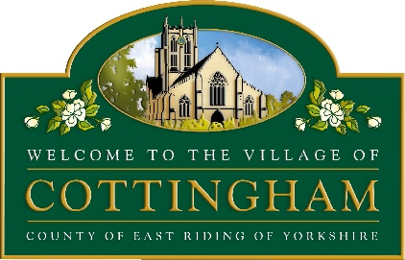

To Electors of Cottingham Parish 16th April 2025

Notice of Meeting

The Annual Meeting of the Parish of Cottingham will be held at Cottingham Civic Hall, Market Green, Cottingham at 6pm on Wednesday 23 April 2025.
The Business to be transacted is as follows:
- Apologies
- To appoint Chairperson of the Annual Parish Meeting (this will be Chairman of the Parish Council if present)
- To adopt the Minutes of the Parish Meeting held on Thursday 17 April 2024
- To receive the report of the Chairman of the Parish Council
- Electors Question and Answer Session
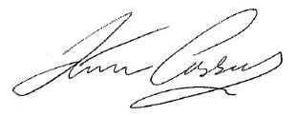
Kevin Casson
Chairman of Cottingham Parish Council

This meeting will form part of the Cottingham Network Evening where you can meet representatives of community groups, take part in a quiz and enjoy nibbles while you network!

