Cottingham Parish Council

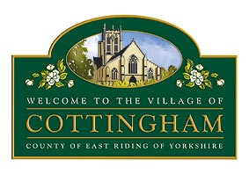

To Members of the Allotments Committee

14th January 2025

Dear Member,

### **ALLOTMENTS COMMITTEE MEETING**

I hereby invite you to attend the meeting of the Cottingham Parish Council Allotments Committee which will be held at the Parish Council Office, 9 The Cottages, Market Green, Cottingham at **6.30pm Tuesday 21st January 2025.** MEETINGS ARE OPEN TO MEMBERS OF THE PUBLIC AND CAN BE JOINED REMOTELY VIA MICROSOFT TEAMS MEETING ID: 375 929 344 813 Passcode: qg7gM6mo

**Nicola Pape**

Nicola Pape

Clerk to Cottingham Parish Council

All mobile phones and other electronic devices should be switched to mute and only used to facilitate this meeting. The public are welcome to attend but are only permitted to speak with the Chair’s permission. Parish Council Meetings are meetings held in public, not public meetings.

The Business to be transacted is as follows:

1. **Declarations of Interest**
   1. To record declarations of interest by any member of the Committee in respect of the agenda items listed below. Members declaring interests should identify the agenda item and type of interest being declared.
   2. To note dispensations given to any member of the Council in respect of the agenda items listed below
2. **To receive & approve apologies**

**Administration**

1. **To receive an update on the allotments budget**
2. **To review arrangements for inspections of plot scoring consistent 5’s**
3. **To consider use of retained deposits**

**Social/Community Activity**

1. **To receive update on Allotment Association activity**
2. **To agree future meeting dates**
3. **Exclusion of the Press and Public: It is recommended that the public and press be excluded from the Meeting for the consideration of the following matters on the grounds that it involves the likely** **disclosure of confidential information as defined in Section 1 (2) of the Public Bodies (Admission to Meetings) Act 1960**.
4. **To consider an appeal against a withheld deposit**