Cottingham Parish Council

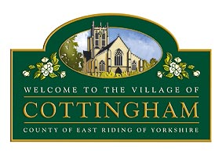
To Members of the Cottingham Parish Council 9th October 2024
Planning Committee

Dear Councillor

PARISH COUNCIL PLANNING COMMITTEE MEETING

I hereby summon you to attend the next meeting of the Cottingham Parish Council Planning Committee which will be held at The Parish Council Office, 9 The Cottages, Market Green, Cottingham, at 7pm, on Tuesday 15th October 2024. I have attached a list of Notices of Decision and Applications for your information.
The meeting will be available to view via Microsoft Teams. Meeting ID: 344 373 077 182 Passcode: T5kLDX

Parish Council Planning meetings are held in public, they are not public meetings. Members of the public are welcome to attend meetings as observers only, however, at the Chairman's discretion, residents may be permitted to comment on a specific planning application. It should be noted that the Parish Council is one of many Planning Consultees and East Riding of Yorkshire Council make the final decision. Members of the Public can post comments directly onto East Riding of Yorkshire Council Planning Portal by visiting their website.

Nicola Pape

Nicola Pape, Clerk to the Cottingham Parish Council

The Business to be transacted is as follows:

1. Declaration of Interests

2. To receive and approve apologies

3. To receive Correspondence & Notices of Decision (see attached sheet)

4. To consider Planning Applications outstanding since the date of the last Meeting (see attached sheet)

5. To consider the targeted consultation on proposed application for development consent - proposed Peartree Hill Solar Farm

6. To receive update on s106 monies due from planning application 24/02672/STVAR - Site of Needler Hall, Northgate, Cottingham 6. Items for the next agenda (Discussion items only)

7. To discuss Planning training for Councillors

8. Items for the next agenda (Discussion items only)

