Cottingham Parish Council

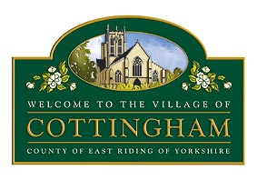
To Members of the Allotments Committee
9 July 2024

Dear Member,

ALLOTMENTS COMMITTEE MEETING
I hereby invite you to attend the meeting of the Cottingham Parish Council Allotments Committee which will be held at the Parish Council Office, 9 The Cottages, Market Green, Cottingham at 10am Thursday 25 July 2024. MEETINGS ARE OPEN TO MEMBERS OF THE PUBLIC AND CAN BE JOINED REMOTELY VIA MICROSOFT TEAMS MEETING ID: 337 764 589 184 Passcode: 34JYcz
Jane Price

Jane Price
Clerk to Cottingham Parish Council

All mobile phones and other electronic devices should be switched to mute and only used to facilitate this meeting. The public are welcome to attend but are only permitted to speak with the Chair’s permission. Parish Council Meetings are meetings held in public, not public meetings.

The Business to be transacted is as follows:

- Election of Chair
To elect a chair for the 2024/25 Municipal Year

- Declarations of Interest
  - To record declarations of interest by any member of the Committee in respect of the agenda items listed below. Members declaring interests should identify the agenda item and type of interest being declared.
  - To note dispensations given to any member of the Council in respect of the agenda items listed below

- To receive & approve apologies

Administration
- To receive an update on the allotments budget
- To provide an update on proposals to waive rent in certain circumstances
- To review arrangements for plot inspections and plot handovers
- To consider issues arising from waterlogged plots
- To consider request for funding for secure metal shed

Social/Community Activity
9.1 Open Gardens
  - Plant Sale

10. To agree future meeting dates

