Cottingham Parish Council
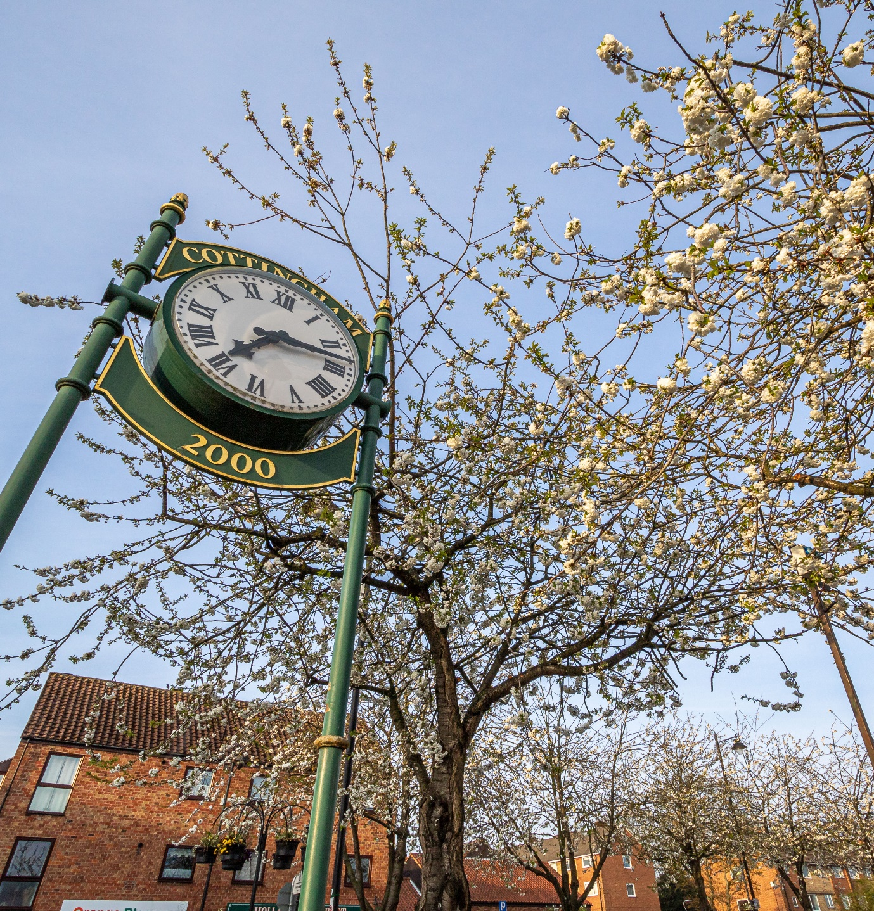

Strategic Plan 2024 - 27

Introduction
The historic settlement of Cottingham is said to be the largest village in England and now has a population of over 17,000. It has an award-winning market and a thriving retail centre, as well as an active community and voluntary sector. The village has a wide variety of food outlets and a vibrant nightlife including a wide range of activities and entertainment at the Cottingham Civic Hall, Darby and Joan Hall and local churches. However, it also faces issues arising from financial pressures affecting both residents and businesses, traffic congestion, anti-social behaviour and flooding.
Whilst Cottingham parish falls into the administrative area of the East Riding of Yorkshire Council which provides services at a county wide level, Cottingham Parish Council provides a range of local information, support and services to the community. We are consulted on things like planning, public transport, road improvements, mineral and waste policy, and crime prevention. We also provide local amenities such as allotments, bus shelters and litter bins and make grants to support village clubs and charities as well as organising the highly successful Cottingham Day and Festival of Christmas events.
Financed principally through the precept with some small amounts of finance from other sources, the Parish Council wants to make the best use of its funding to address issues of importance to the well-being and future development of the village. The Council believes it has a direct role to play in the social, economic and environmental wellbeing of the parish and ensuring it plays its part in the wider economy of the Humber region. It has produced a plan setting out its strategic priorities for the next three years to help meet these aspirations. The plan sets out detailed actions for the next financial year and identifies the resources required to deliver them. The Council recognises it cannot achieve its ambitions alone and aims to work with other organisations, community groups and local residents to identify and implement projects which benefit the parish and contribute to its development.
The Plan will be reviewed annually and will be used to inform the budgeting process, to plan activities for the forthcoming year and enable the Parish Council to monitor its progress against its agreed priorities.

Councillor Kevin Casson
Chairman

Vision
The Parish Council has agreed that it wants Cottingham to be

‘a strong and vibrant community where residents, businesses and voluntary organisations thrive’

Aims
It has set out a series of aims and aspirations for the parish for 2024 - 2027
  - A resilient community with a good quality of life, working towards a sustainable, greener future
  - A thriving village centre
  - Attractive and clean public realm
  - A population that is healthy and feels safe
  - Green spaces that are accessible to the whole community
  - A vibrant community and voluntary sector
  - An effective and well-run Council

Priorities 2024- 2025
To help it deliver its long-term vision and aspirations, the Council has agreed the following priorities for 2024 - 2025

Priority 1 To maintain the quality of the built environment through effective engagement with the planning process
Priority 2 To progress the “Town Centre” Project
Priority 3 To work with the Police and other agencies to address ASB
Priority 4 To develop the QE Memorial Garden and the Memorial Gardens
Priority 5 To work with local organisations to promote and develop environmental improvements and green spaces
Priority 6 To further develop events including the Cottingham Day and Christmas Festivals
Priority 7 To ensure the Council operates efficiently and effectively and has strong leadership

Actions 2024-25
Each priority has been broken down into a series of actions for 2024-25 taking account of available resources. Progress will be measured against these actions and reported regularly to the Parish Council. A formal review will take place in October 2024 to identify actions for 2025-26.

Actions | Timescale | Resources required | Measures of success | Monitoring
Priority 1 - To maintain the quality of the built environment through effective engagement with the planning process
To continue to monitor all planning applications that affect the parish and submitting comments to the Planning Authority as necessary | Ongoing | Planning committee members  Staff time | Comments on all applications relating to Cottingham
To review compliance with the Neighbourhood Plan | Ongoing | Planning committee members | All applications compliant with the Neighbourhood Plan
To review proposed amendments to planning policies/Plans | As required | Staff Time  Planning Committee members | Response submitted to all consultations
To consider infrastructure projects affecting the parish | As required | Traffic surveys  Alternative energy plans  Local Plan  Budget required for any initiatives proposed | Responses submitted to consultations  Proposals developed to address specific identified issues/opportunities
To investigate a Blue Plaque Scheme and Heritage Trail for the village | Proposals to be produced by December 2024 | Support from Local History Society (LHS)  Councillors  Staff time  Funding/grant | Agreement to proposals and identification of suitable individuals for blue plaques
Priority 2 - To progress the “Town Centre” Project
To pursue funding for a Town Centre Officer post | Ongoing | Funding provision in 2024/25 budget | Funding obtained
To work with local businesses and traders to develop and implement an improvement plan | March 2025 | Town Centre Officer (TCO) in post  Involvement of local businesses | Production of an agreed improvement plan
To network with other Town Centre Officers to share ideas and good practice | Ongoing | TCO in post | Identification of transferable actions/initiatives
To develop events that promote the village ‘offer’ | March 2025 | TCO in post  Funding/grant | Number of additional events
To identify and pursue external funding for projects which benefit the parish | Ongoing | TCO in post | Number and amount of additional grants received
Priority 3 – To work with the Police and other agencies to address ASB
To work with Humberside Police to reduce crime and anti-social behaviour | Ongoing | Staff time | Reduction in ASB/Crime
To investigate use of the Beats Bus as a diversionary activity | By July 2024 | Grant funding to be identified | Reduction in ASB
To identify other diversionary activities | Ongoing | Grant funding to be identified | Reduction in ASB
To develop and promote a Shopwatch scheme | By May 2024 | Staff time  Councillors  Business commitment | Number of businesses signed up to the scheme  Reduction in shop theft
To work with other agencies eg Fire Brigade to promote community safety | Ongoing | Staff time  Involvement of partners  Funding to support any proposed initiatives | Proposed projects/initiatives
To review concerns about road safety and air pollution in liaison with ERYC/Humberside Police | Ongoing | Staff time  Councillors  East Riding of Yorkshire Council (ERYC)  Humberside Police | Identification of possible projects to address concerns  Development and costing of projects
Priority 4 – To develop the QE Memorial Garden and the Memorial Gardens
To create development plans for both sites | July 2024 | Staff time  Councillors  Input from residents  Budget provision included in 2024/25 budget | Development plans in place
To liaise with ERYC regarding proposals for the QE Memorial Garden | April – July 2024 | Staff time  Councillors | Agreement from ERYC for proposals
To develop a ‘Friends’ group for the QE Memorial Gardens | December 2024 | Councillors  Staff time  Budget provision included in 2024/25 budget | Friends Group established  Number of members involved
To agree a planting plan for the Memorial Gardens | December 2024 | Councillors  Budget included in 2024/25 budget | Planting plan in place
To investigate proposals to develop an area suitable for wedding photographs etc | July 2024 | Staff time  Review of requirements  Liaison with organisations involved in wedding planning  Funding for any proposals | Plan developed  Funding identified  Usage  Feedback from visitors
Priority 5 - To work with local organisations to promote and develop environmental improvements and green spaces
To work with Cottingham Unity and other groups to develop planting schemes around the village including the improvement of verges | Ongoing | Councillors  Residents  Budget provision included in 2024/25 budget | Number of planting schemes  Residents involved in local groups  Volunteers
To review street furniture | September 2024 | Councillors  Staff time  Budget required to fund any additions/removal | Proposals regarding improvements, replacement, removal
To maintain and improve village planters | September 2024 | Staff time  Budget required to repair or replace planters | Improvement plan developed
To develop and implement Cottingham in Bloom | March 2025 | Staff time  Councillors  Budget provision included in 2024/25 budget | Feedback from trial  Plan developed for expansion in 2025/6
To work with the Cottingham Northgate Allotments Association (CNAA) to effectively manage and develop the Northgate allotment site | Ongoing | Staff time  CNAA | Feedback from allotment holders  Improvement to allotment facilities
To investigate opportunities to provide additional allotments | March 2025 | Staff time | Site identified  Plans developed to progress
To work with KGV Cottingham Community Trust to improve play and activity provision at the Playing Fields | Ongoing | Staff time  Councillors  Grant funding to provide any equipment required | Updated survey produced  New equipment installed  Feedback from users
Priority 6 – To further develop events including the Cottingham Day and Christmas Festivals
To review supporting documentation for events eg risk assessments/traffic management plans | May 2024 | Staff time  Budget for any additional plans required | Policies and procedures updated
To identify any improvements required in response to feedback from traders/visitors | May 2024 | Staff time  Events Working Party | Improvement plan developed
To investigate wider promotion of the events | July 2024 | Staff time  Events Working Party | Increase in visitor numbers  Increase in percentage from outside of area
To consider mechanisms to broaden the range of stalls/traders | April 2024 | Staff time  Events Working Party | Improvement plan developed
To work with local musicians/entertainers to broaden the range of performances | July 2024 | Staff time  Events Working Party | Improvement plan developed
To investigate payment options for rides etc to add capability to take card payments | July 2024 | Staff time | Card payment option in place
To document processes to reduce risk of reliance on individuals’ knowledge | May 2024 | Staff time | Processes documented  Contingency plan developed
To work with the Town Centre Officer to develop additional events | Ongoing | TCO in post  Staff time | Number of additional events
Priority 7 - To ensure the Council operates efficiently and effectively and has strong leadership
To develop and implement policies and procedures that ensure good governance | Ongoing | Staff time  Councillors | Review of Standing Orders and Financial Regulations  Number of policies developed or reviewed  Number of COC complaints  Attendance and participation at meetings  Agenda and minutes produced in a timely fashion
To ensure that good financial practices are followed and value for money obtained | Ongoing | Staff time | Unqualified audit
To review the Parish Council’s grant schemes | March - July 2024 |  | Increase in applications  Wider range of groups applying
To review Cottingham’s Emergency Plan | July 2024 | Staff time  Councillors | Revised an updated plan
To invest in improvements to the Council’s IT systems and website | Ongoing | Staff time  Training | Number of computers replaced  New audio-visual system in place  Number of Councillors using CPC email addresses
To improve the Council’s social media presence | Ongoing | Training  Staff time | Number of posts  Feedback
To ensure that the Council complies with good employment practices | Ongoing | Councillors  Staff time | Number of grievances  Number of applications for vacancies  Feedback from staff through appraisals
To provide advice and information to residents/other agencies as appropriate | Ongoing | Staff time  Councillors | Number of residents supported  Feedback
To develop and implement a training plan for staff and councillors | May 2024 | Personnel Committee  Staff time  Funding for training | Training plan in place  Number of training courses attended
To work with ERYC to improve liaison between the Parish and principal council | Ongoing | Staff time | Feedback from Councillors/staff  Improved response time for queries  Number of joint initiatives

